**Data Analysis of  oceanfront boroughs in Rio de Janeiro - Housing Sales/Rental Prices,Venues & International Schools.**

Cecília Meireles Andries

August 06, 2020

**INTRODUCTION**

Rio de Janeiro is known as the “Wonderful City” and it is famous worldwide. It´s the most important tourist spot in Brazil. There are many beautiful places, especially amazing beaches. It´s considered by UNESCO as a cultural landscape. The weather is perfect, about 23 degrees all year around.

I´ve been living here for decades, and I had the opportunity to see the city grows and develops with events such as the Soccer World Cup and the Olympic Games. I think the events that took place in the city attracted many foreign investors, especially for the real estate market. In addition, the city receives many foreign employees from multinational companies every year. However, these companies have some difficulties when these employees arrive in Rio. They have to find a house and an international school for their families.

Therefore, I decided to do my project about oceanfront boroughs in Rio de Janeiro city, due to the fact that it is the most desired place to invest, live and visit. The most important tourist spots are in or around these boroughs, as well as many offices and main shopping centers. If a brand needs to get attention in Brazil, it will have to open a store in one of them. This project will be interesting for investors, multinational companies, tourists, foreign and Brazilian people.

**DATA**

In the first place, I got the data about housing average sales prices and average rental prices per square meters in SECOVIRIO – Housing Union (<https://www.secovirio.com.br/wp-content/uploads/2020/07/precos-dos-imoveis-jul20.pdf>). The data was cleaned, reduced and separated. The information about housing average rental prices per square meters was plotted on vertical bars graph and housing average sales prices per square meters on horizontal bars graph. After that, I got in official government website of INEA – Instituto Estadual do Ambiente (<http://www.inea.rj.gov.br/wp-content/uploads/2018/12/Coordenadas-Geogr%C3%A1ficas-das-Esta%C3%A7%C3%B5es-de-Amostragem-Praias.pdf>) a file with all the beaches coordinates. It was also used the .json file in all areas of Rio de Janeiro´s boroughs from other official government website of Instituto Pereira Passos (<https://opendata.arcgis.com/datasets/8454eb0454b7424d89c61b67742286a1_15.geojson>). And that data was cleaned and reduced to just oceanfront boroughs. Therefore, with this information, I created a choropleth map of Housing sales price.

About international schools, I searched in Google and checked all the information. This data was combined into the table with boroughs and then changed from category data to numeric data. A pie chart was created to visualize number of schools by boroughs.

Foursquare API (<https://developer.foursquare.com/>) was used to get the most common venues about oceanfront boroughs. In this case, I showed venues about the boroughs as well as I used unsupervised learning K-means algorithm to cluster the boroughs.

Finally, a choropleth map was plotted with all information about oceanfront borough such as housing average sales price per square meters, international schools and clusters. Thus, with all information, it´ll be easier to investors, multinational companies or anyone to choose the better place in Rio de Janeiro according their needs.

**METHODOLOGY**

The focus of this project is on oceanfront boroughs in Rio de Janeiro. The following elements were analyzed: housing average sales price per square meter, as well housing average rental price per square meter, latitude, longitude, international schools and venues in Foursquare (Figure 1 and 2).

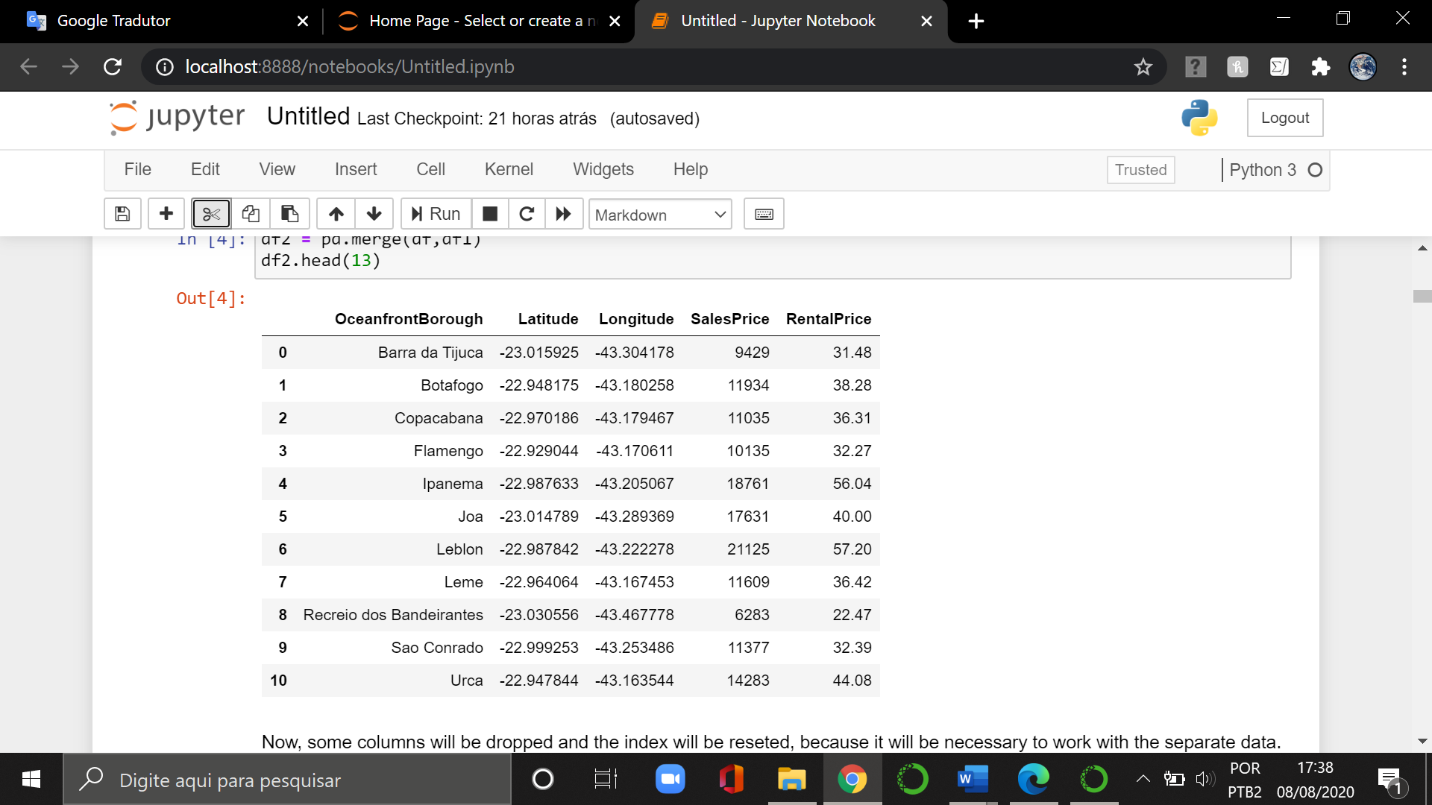

Figure 1. Oceanfront borough in Rio de Janeiro.

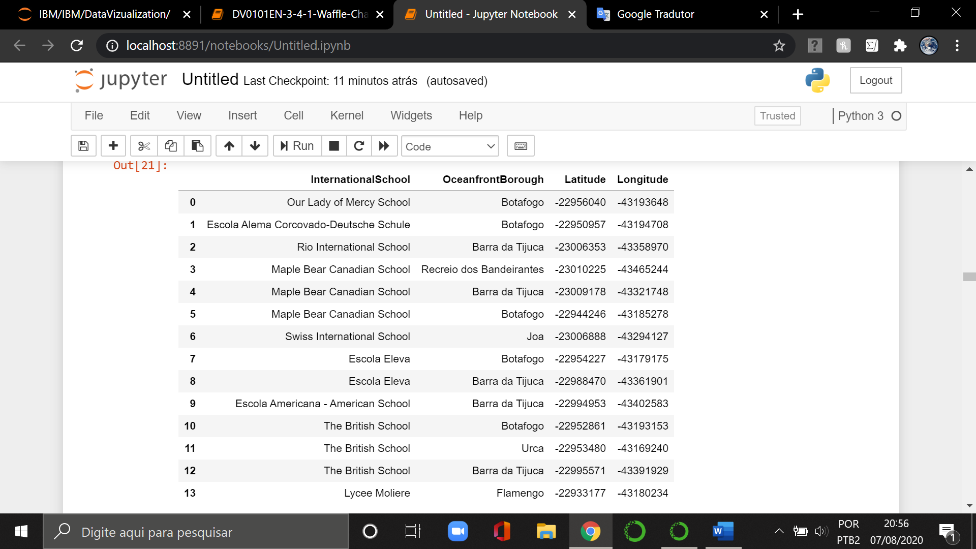

Figure 2. International schools in oceanfront boroughs in Rio de Janeiro.

After the data was cleaned and separated, I used the Matplotlib to plot graphs to make it easier to visualize each data. We can see below a graph on housing average sales price per square meters and another on housing average rental price per square meters (Figure 3 and 4). The sales and rental prices are in currency of Brazil (REAL). I didn’t use it in dollar due to the fact that there is a lot of exchange fluctuation in the currency of Brazil.

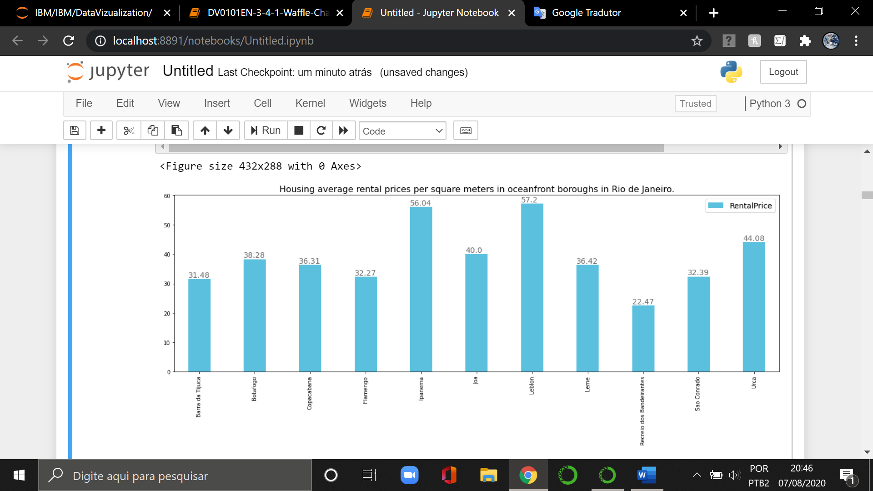

Figure 3. Housing average sales price per square meters in oceanfront boroughs in Rio de Janeiro.

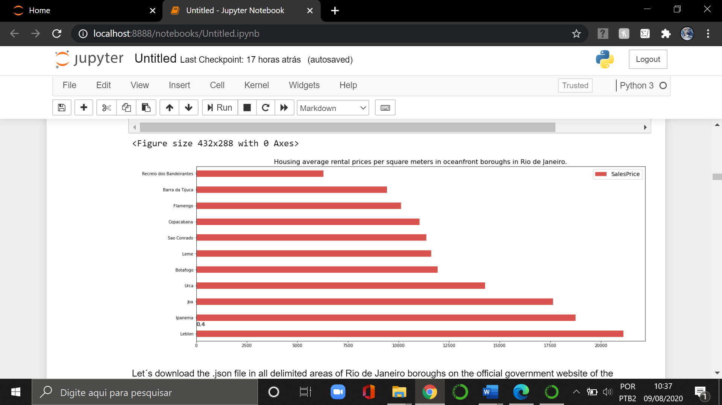

Figure 4. Housing average sales price per square meters in oceanfront boroughs in Rio de Janeiro.

As you can see in the graphs, there is a quite difference in the rental/sales values. Although all these boroughs are facing the sea, they have their peculiarities.

Another data used are International schools. After searching in Google and checking all the information, I created a file (Figure 2). I found English, French and German schools. And these data were worked on to know how many schools there are in each oceanfront borough. Next, I plotted a pie chart (Figure 5) so that we can see this data in a better way.

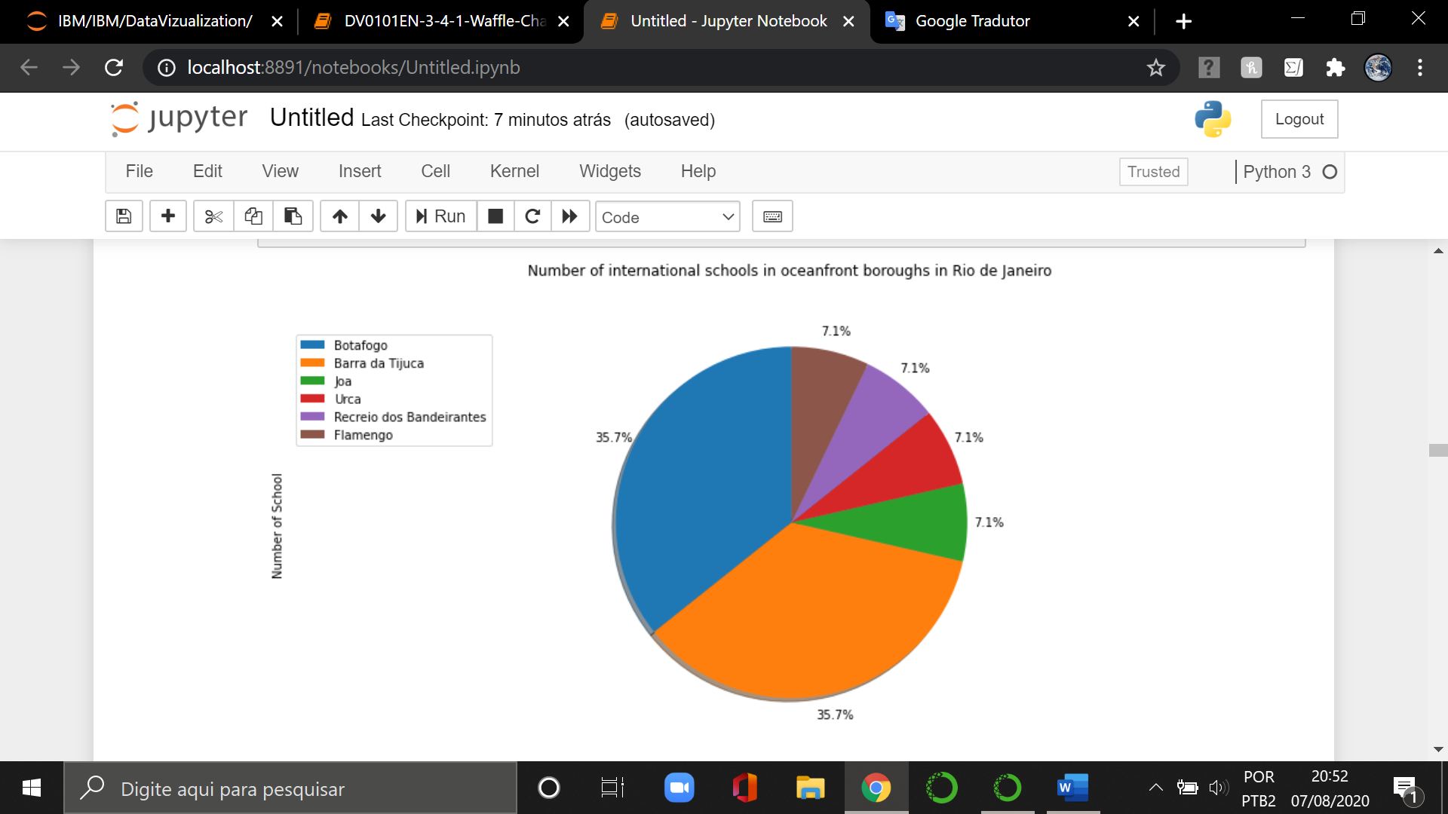

Figure 5. Number of International schools in oceanfront boroughs in Rio de Janeiro

Python folium library was used to plot all the maps in this work due to visualize geographic details of Rio de Janeiro, which has 163 boroughs and 84 kilometers of beaches. First, a map was plotted with delimitation areas of all boroughs in the city (Figure 6). Second, I cleaned the data e plotted a map of just oceanfront boroughs (Figure 7).

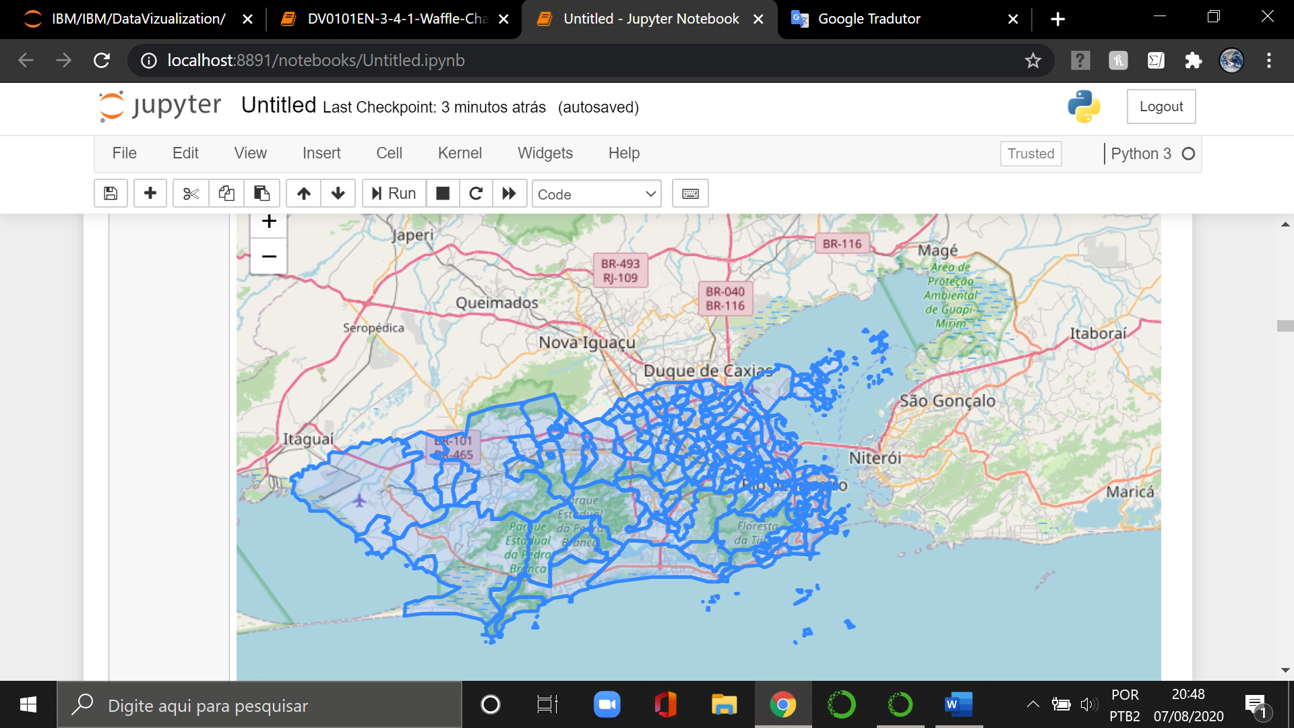

Figure 6. Delimitation areas of all boroughs in Rio de Janeiro.

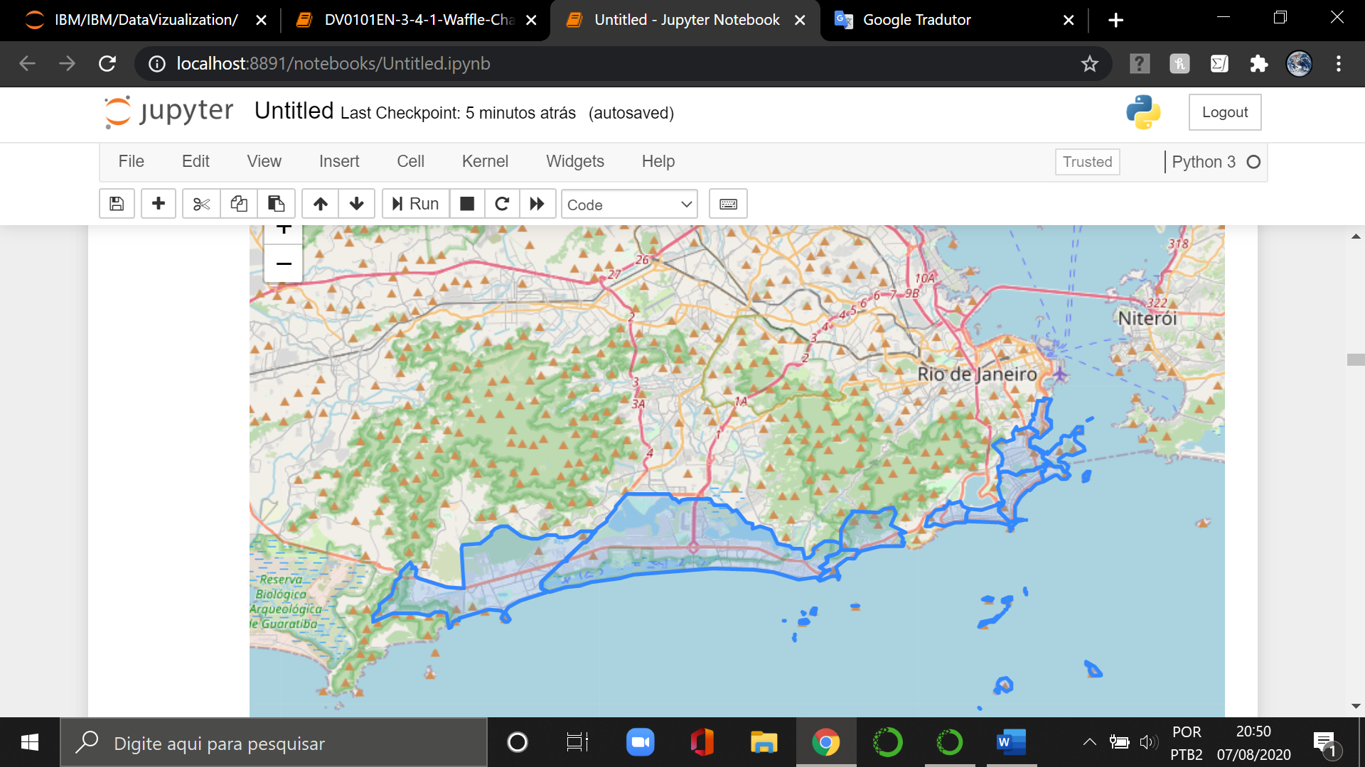

Figure 7. Delimitation area of just oceanfront boroughs in Rio de Janeiro.

Again, I plotted the same map, but now it was used just one latitude and longitude coordinates of each oceanfront borough (Figure 8).

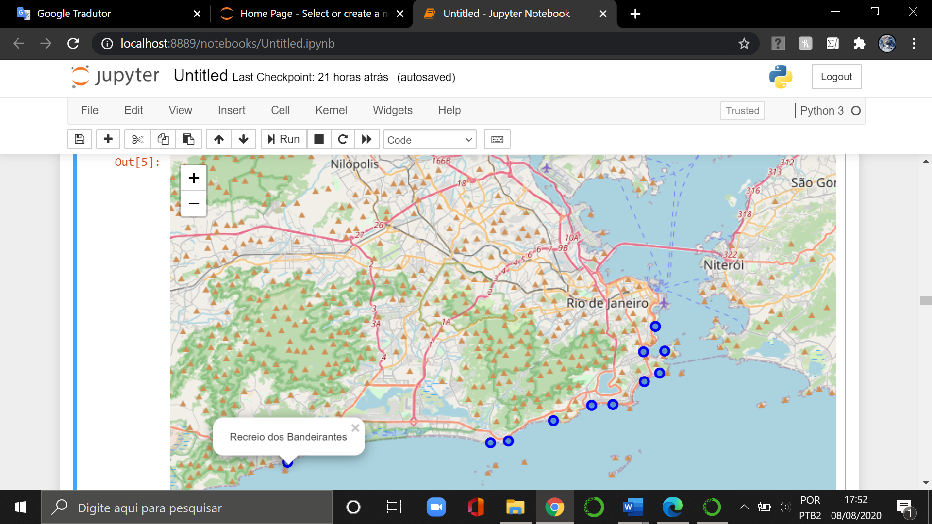

Figure 8. Oceanfront boroughs in Rio de Janeiro.

Finally, I combined information on housing average sales price per square meters with delimitation areas of oceanfront boroughs in Rio de Janeiro in order to visualize the data better (Figure 9).

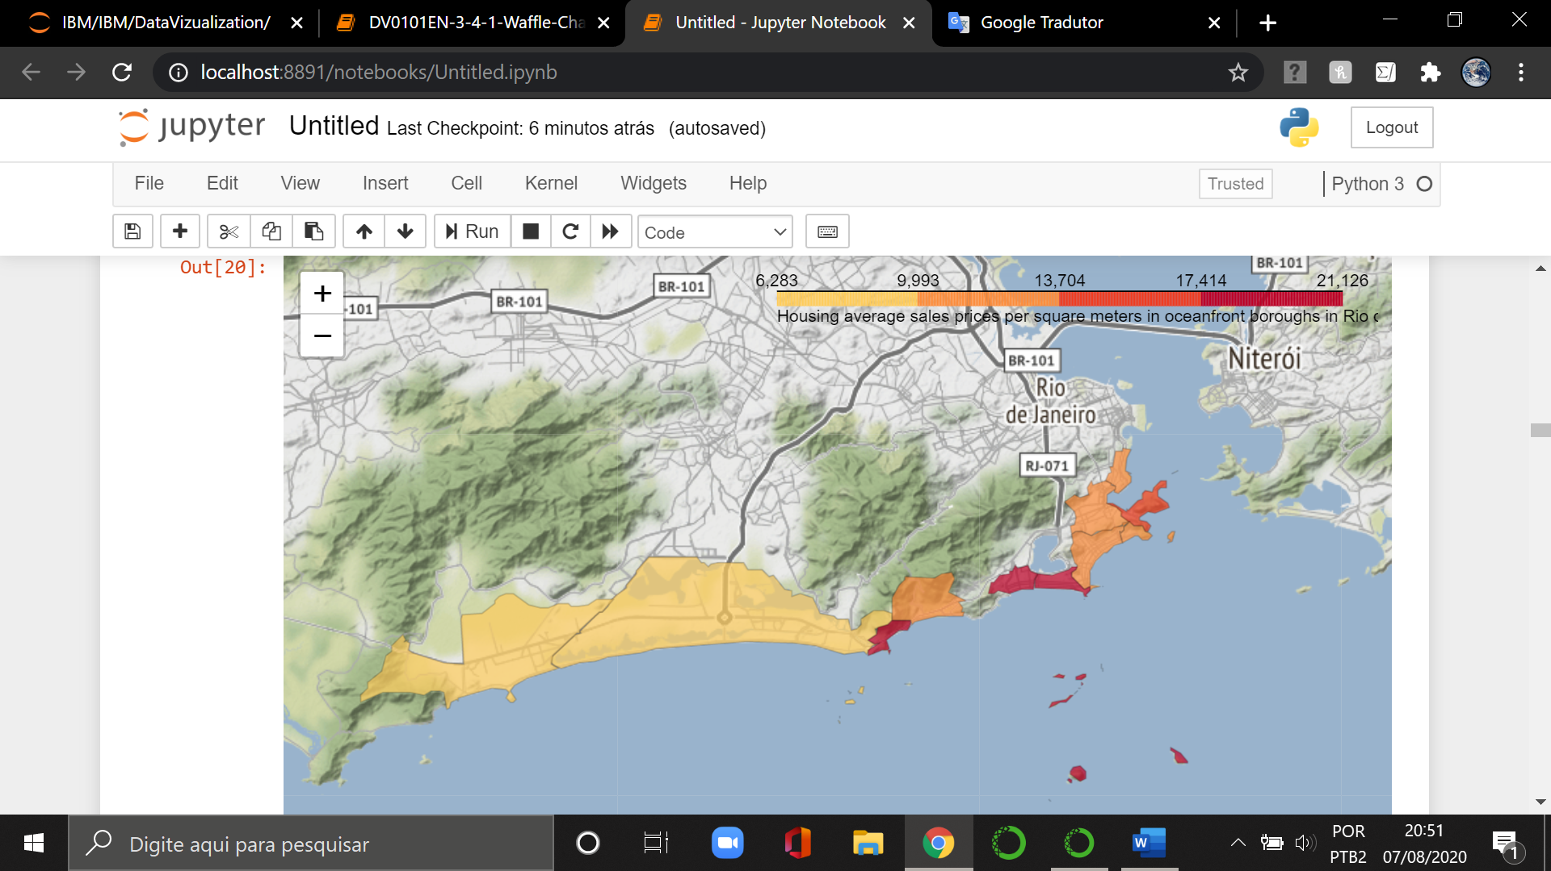

Figure 9. Housing average sales price per square meters in oceanfront boroughs in Rio de Janeiro.

The Foursquare API is used to explore the oceanfront boroughs. I put the limit at 150 venues and a radius of 850 meters for each borough. I printed a table (Figure 10) with information that was returned by Foursquare. We can notice that there are 406 venue categories in total in oceanfront boroughs.

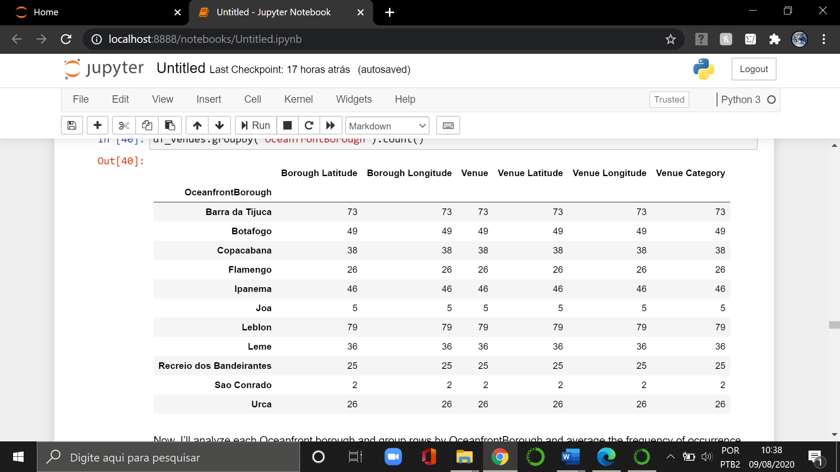

Figure 10. Venues in total in oceanfront boroughs in Rio de Janeiro.

After that, I chose Copacabana because it is the most famous oceanfront borough in Rio de Janeiro. And then I got the information that Foursquare returned, created and printed a partial table (Figure 11) with name of venues, categories, latitude and longitude.

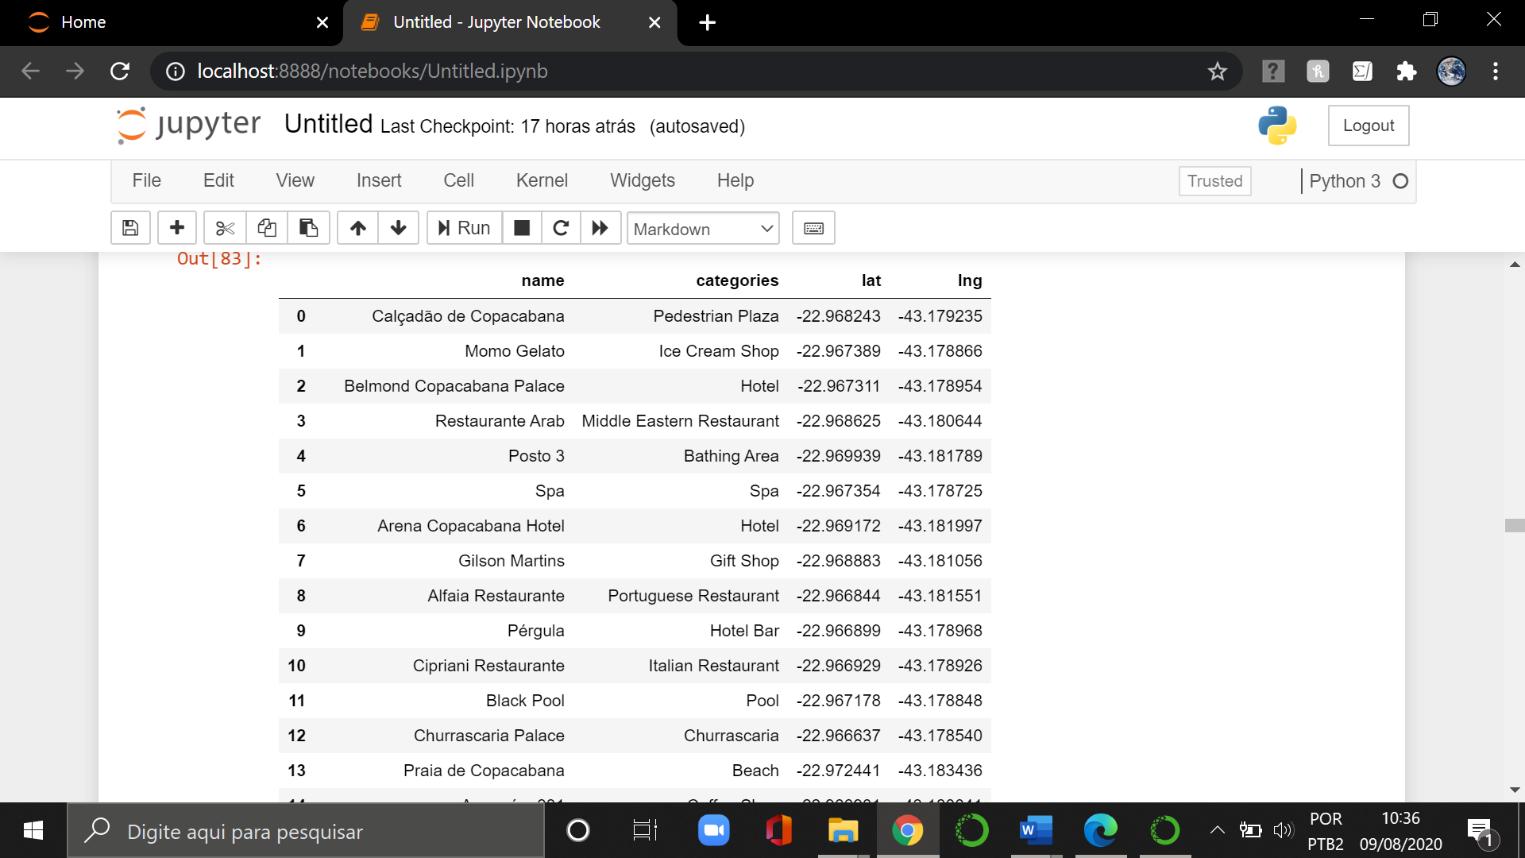

Figure 11. Copacabana venues name.

Lastly, I used unsupervised learning K-means algorithm to cluster the oceanfront boroughs. K-Means grouped the oceanfront boroughs into 5 clusters as we can see a map below (Figure 12).

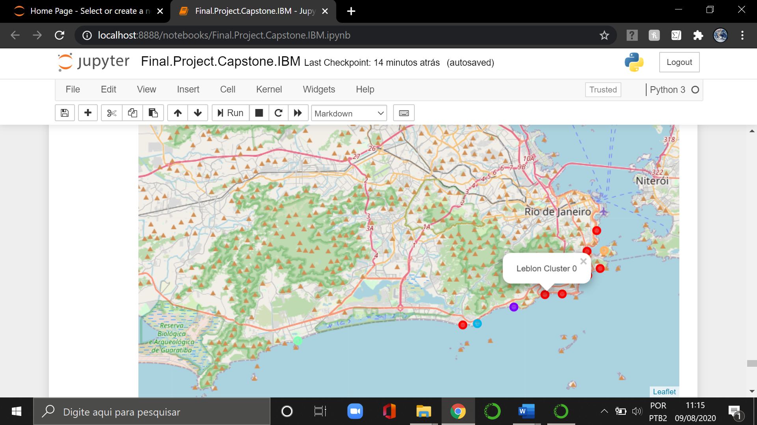

Figure 12. Clusters oceanfront boroughs in Rio de Janeiro.

The clusters are the following:

1 – Recreio dos Bandeirantes;

2 – Joá;

3 – São Conrado;

4 – Urca;

5 – Barra da Tijuca, Leblon, Ipanema, Copacabana, Leme, Botafogo and Flamengo.

**RESULTS**

As result, I plotted a world cloud map (Figure 13) with all information about Copacabana that was returned by Foursquare because I thought it´s very interesting to see venues categories of this place.

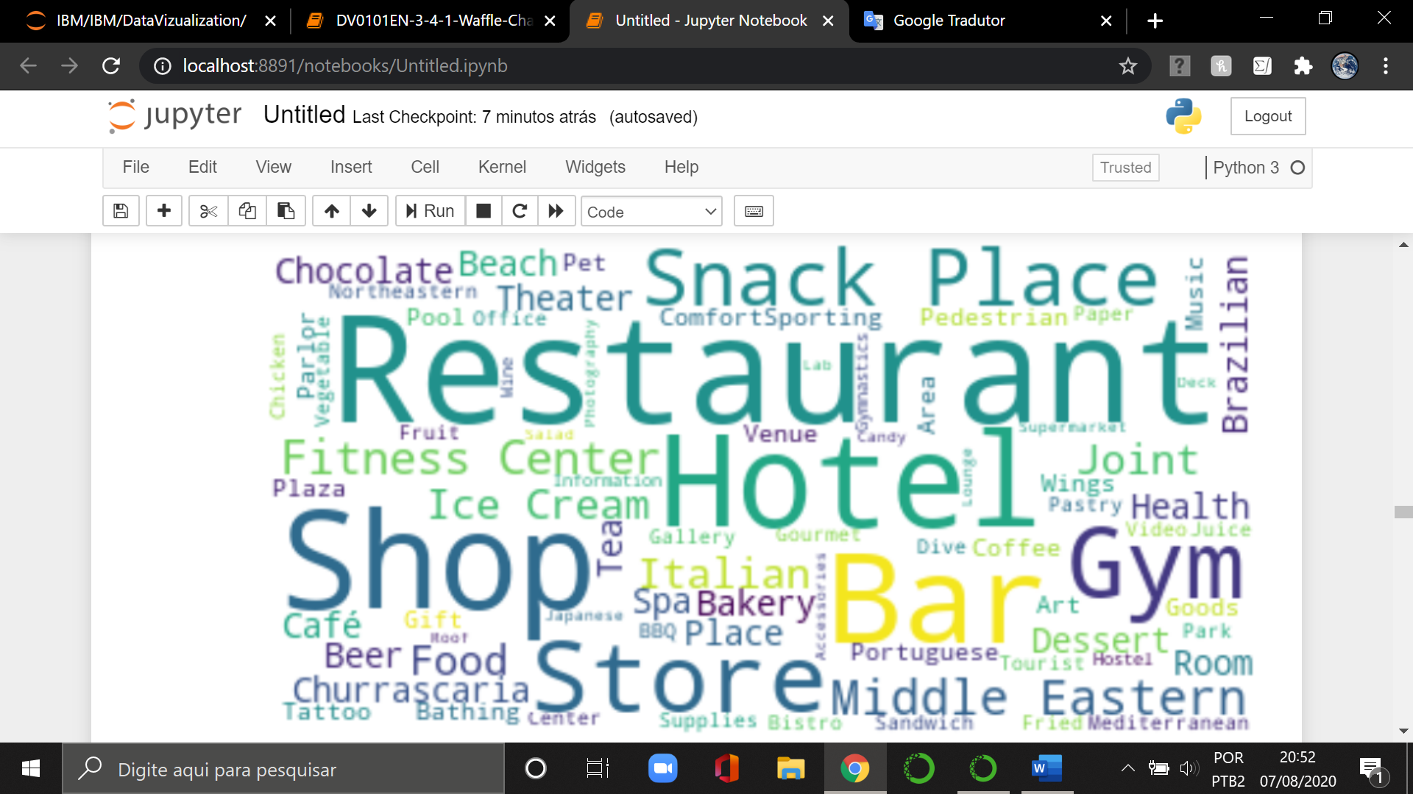

Figure 13. Copacabana venues categories world cloud map

Other results came when I created a table (Figure 14) with the 10 most common venue with International schools in oceanfront boroughs in Rio de Janeiro. It was important to analyze the types of businesses of these boroughs.

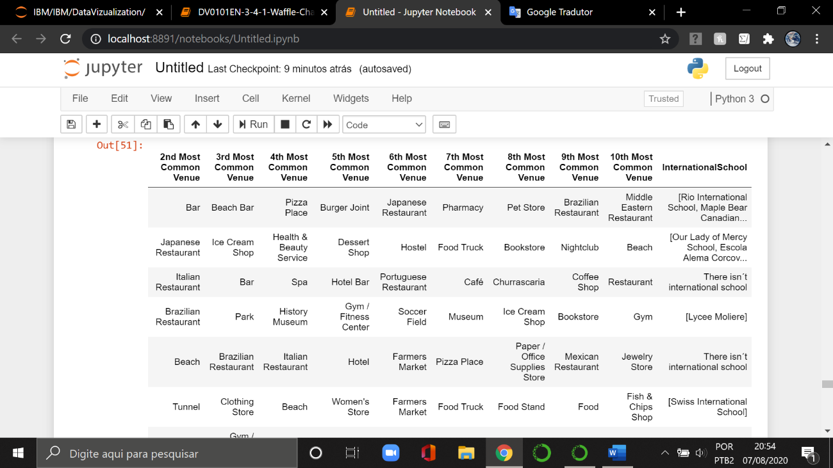

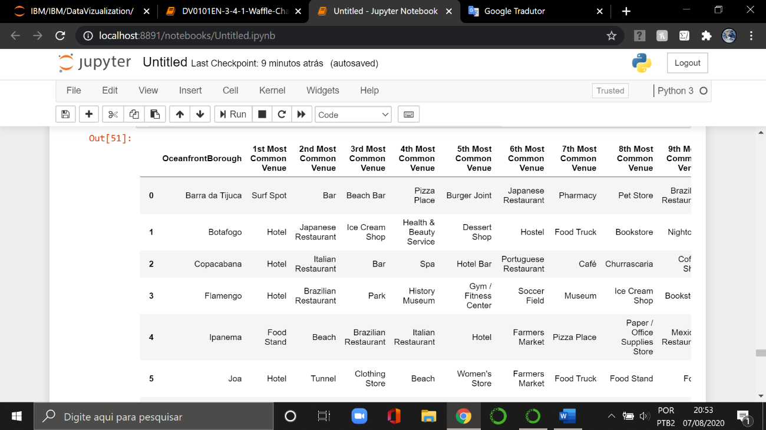

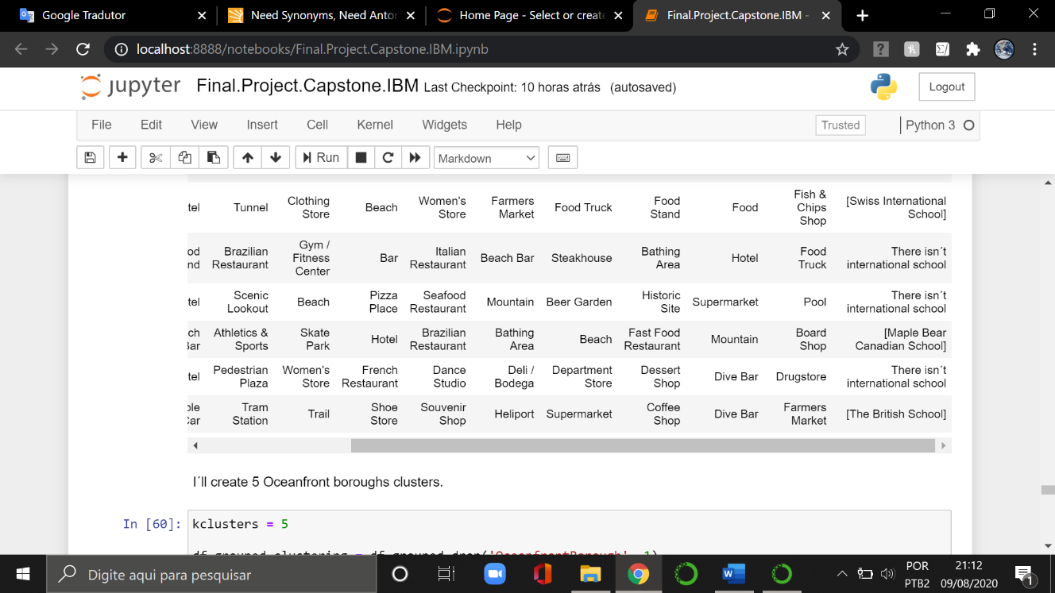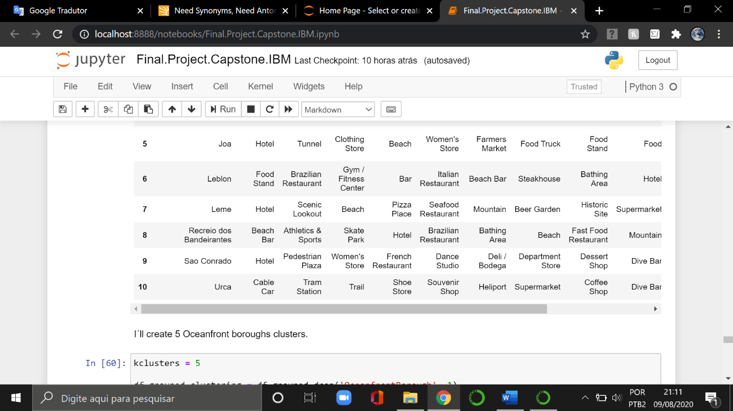

Figure 14. 10 most common venue with international schools

In the end, I attached to the same map with all the information (Figure 15) such as housing average sales price per square meters, international schools, and clusters in oceanfront boroughs in Rio de Janeiro. I figured it would be a lot easier to see all of this information obtained from my work together. I used the choropleth map and when we click on the cluster circle we can see the name of borough and whether there is an international school.

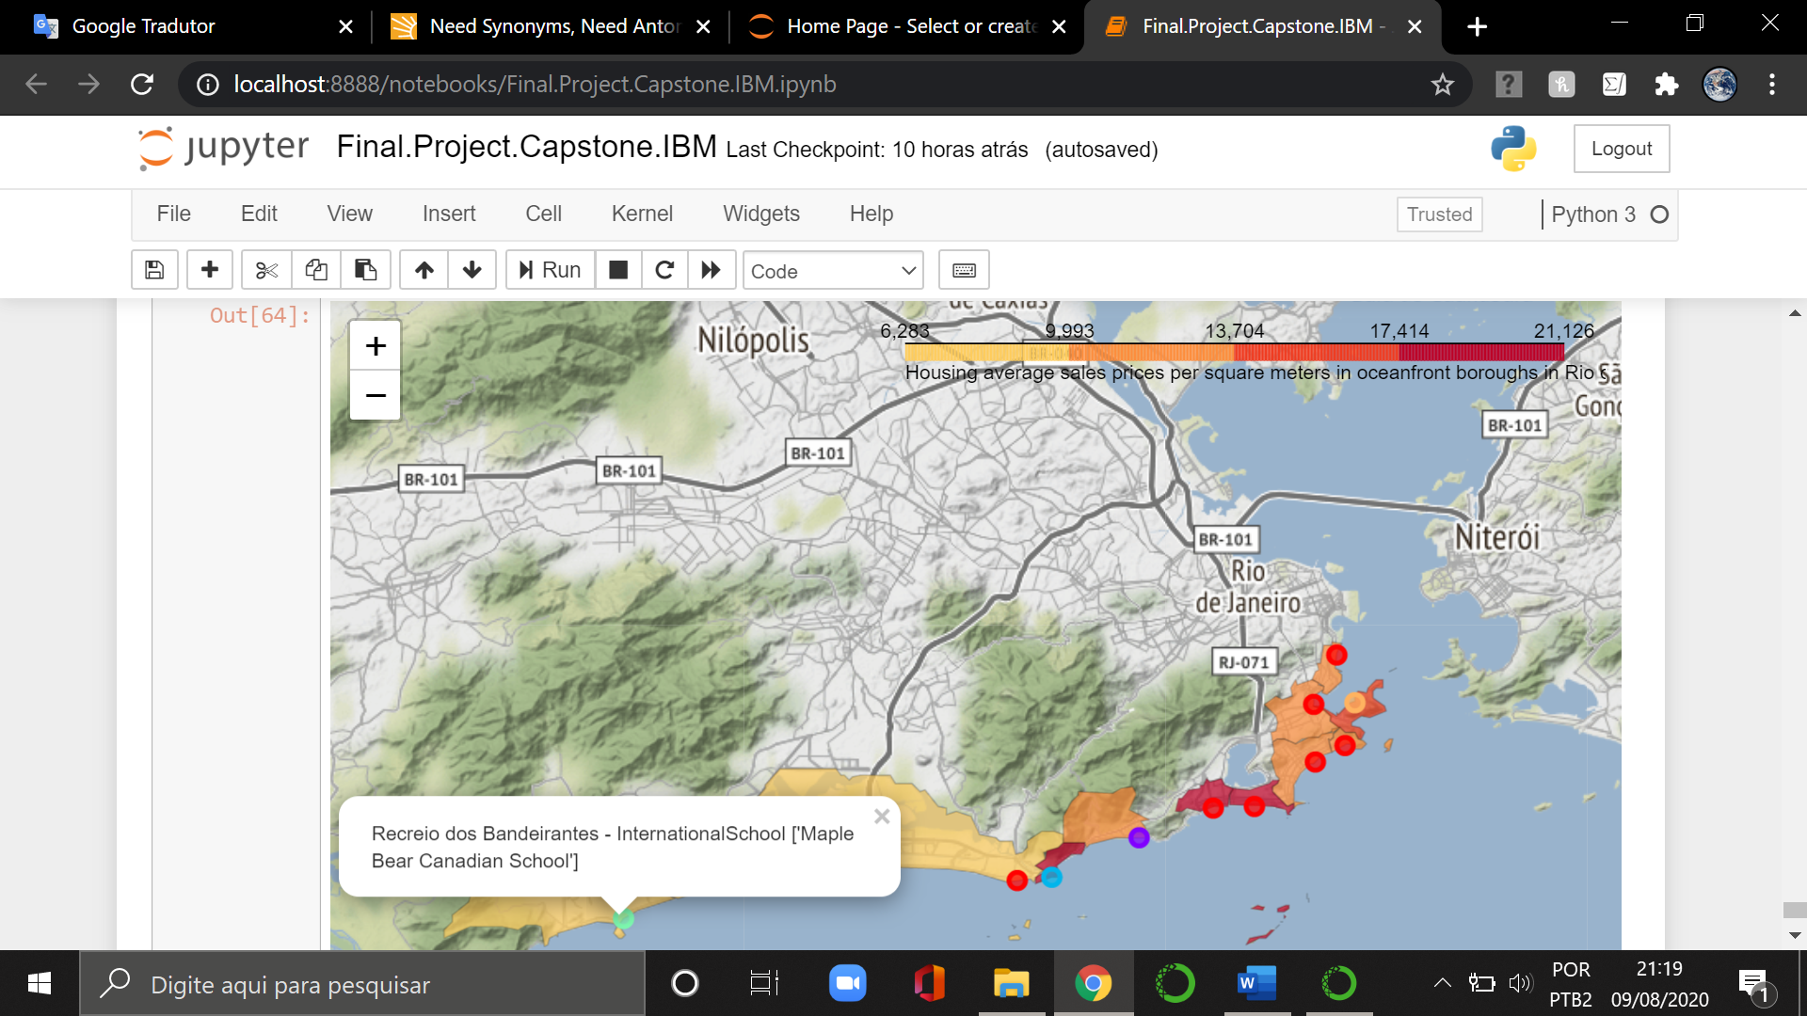

Figure 15. the mat all information.

**DISCUSSION**

Thus, we can note the housing average sales price/rental per square meter is more expensive in Leblon and Ipanema. On the other hand, Recreio dos Bandeirantes and Barra da Tijuca represent about half housing average sales/rental price per square meter when compared to more expensive boroughs.

Companies that need to hire or transfer foreign employees to Rio de Janeiro should consider whether those employees have children. Thus, companies need to cogitate not only the distance between the office and their employees' homes, but whether the boroughs have an international school. The boroughs with the largest number of international schools are Barra da Tijuca and Botafogo.

Other interesting observation is that both São Conrado and Joá don’t have many venues, although there is a mall in São Conrado. The oceanfront boroughs with the most venues are Leblon and Barra da Tijuca. Both of them concentrate the most famous brands in Rio de Janeiro. If someone is interested to open a business needs to consider this information.

Now, if people choose Copacabana just because it is the most famous borough in Rio de Janeiro, they will see, by the results, there isn’t international school, however there are some interesting venues such as restaurants, hotels, malls and bars, as we have the opportunity to see it in the in the figure 13 in this study.

**CONCLUSION**

The subject of this project is the oceanfront boroughs in Rio de Janeiro, because the most important tourist spots are in or around these boroughs, as well as many offices and main shopping centers.

This project analyzed oceanfront boroughs elements such as housing average sales / rental price per square meter, as well international schools and venues in Foursquare.

The information about these boroughs, identified in this project, can be very useful for investors, multinational companies, tourists, foreigners and Brazilians, if they need to work, live and make business in Rio de Janeiro.